FOREST-16/17/18/19 May 2026 LEOP Doppler Evaluation
Technical report, contact schedule, and reproducibility record
May 2026
1 Executive result 1
2 Contact timelines 2
3 Inputs, contact selection, and measurement counts 3
4 TLE priors 4
4.1 FOREST-16 analysis prior 4
4.2 FOREST-17 analysis prior 4
4.3 FOREST-18 analysis prior 4
4.4 FOREST-19 analysis prior 4
5 Analyzed contacts and results 5
6 Forward model and solver 6
7 Position-error computation 6
8 Frozen-correction forecast 7
9 Controls against leakage and optimistic reporting 7
10 Detailed contact evidence 8

Burst Radio Prior

Previous doppler-only OD experiments relied on a assumption of normally distributed residuals for tuning the optimizer. During the LEOP for ororatech’s Forest-16 to Forest-19, this assumption was proven to be wrong.
Further analysis was performed in the post-pass setting using Gaussian Mixture Models (GMM), where a fit was performed to evaluate the true distribution. It was found that for Burst-Radios operating on KSAT LITE hardware, the doppler noise follows a combined gaussian mixture with zero bias, with one centroid having a

Identified Cluster Centroids:
------------------------------------------------------------
Cluster 0 | Count: 685 | Mean offset: -180.55 Hz | Mean std: 351.24 Hz
Cluster 1 | Count: 78 | Mean offset: +654.08 Hz | Mean std: 29770.65 Hz
Noise points (Cluster -1): 54

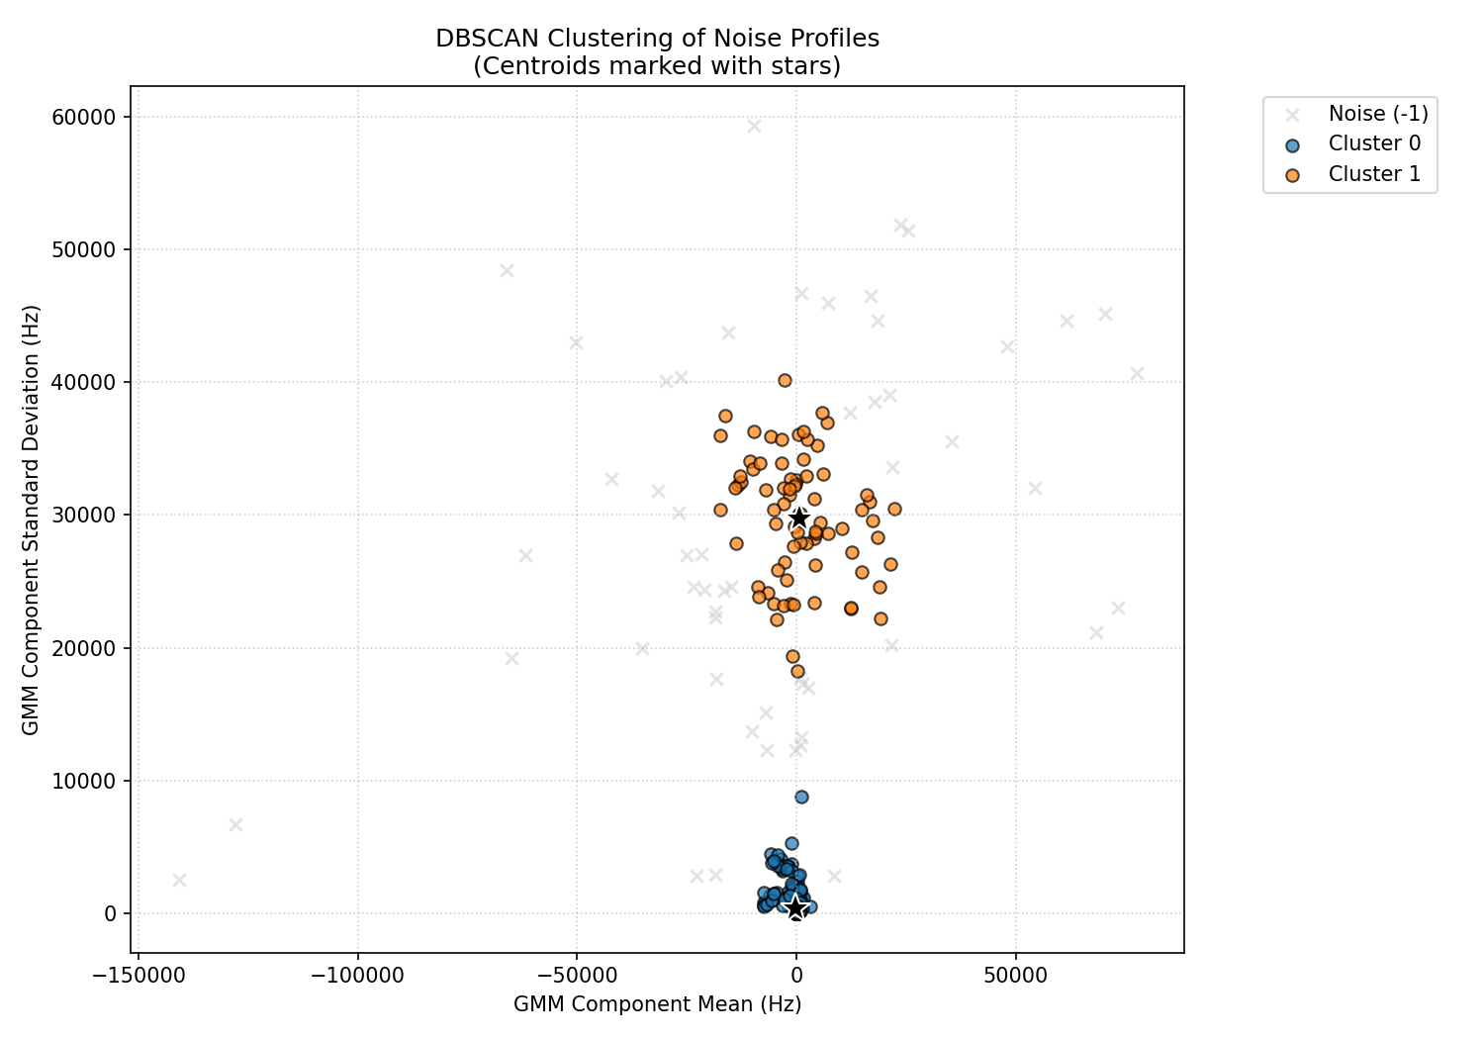

With this knowledge, the optimizer was rewritten to support noise distributions of heavier tails than standard Least Squares, in particular Scipy’s LeastSquare optimizer was chosen, and the Optuna meta-optimizer was chosen to find the ideal combination of configurations. Using this it was found that soft-l1 regularization performs better than huber loss, which assumes a combined Gauss+Laplacian residual distributions.

Re-running experiments, it was also found that the first couple of passes included none of usable quality, in particular a lack of sufficient samples or extreme noise. For this reason a 300-measurement gate was set up as a lower limit for quality, with this gating only 15 out of 61 passes passed. The performance of the optimizer is outlined below.

1 Executive result
This report covers all 61 recorded FOREST contacts from 2026-05-03 09:40:38.191475 UTC through 2026-05-04 05:26:49.694147 UTC. Fifteen contacts contained at least 301 presented Doppler measurements and were fitted; 11 of those had at least five same-pass raw GPS data form the primary accuracy measure.
The production result is a retrospective, full-pass Doppler-only backcast.
Primary-cohort summary: prior-TLE pass medians were 2.437 km best, 9.310 km median, and 21.391 km worst. Full-pass batch-LS pass medians were 0.494 km best, 3.857 km median, and 24.856 km worst; 7 of 11 primary passes improved.
All 15 fits passed the numerical health checks. Of the 14 passes with any same-pass GPS, 10 improved and 4 degraded; none is omitted below. The observed 0.494 km best-pass median is a favourable case, not a guaranteed accuracy.

2 Contact timelines

Figure 1. The 15 estimator-eligible contacts over a 24-hour elapsed-time window. Hollow red outlines in the source figure indicate true duration, not filter failure.
The original production timeline above contains only the 15 contacts that included more than 300 measurements, as this was found to be a floor for effective performance. The following UTC overview adds the 46 excluded contacts and uses filter-status colors directly.
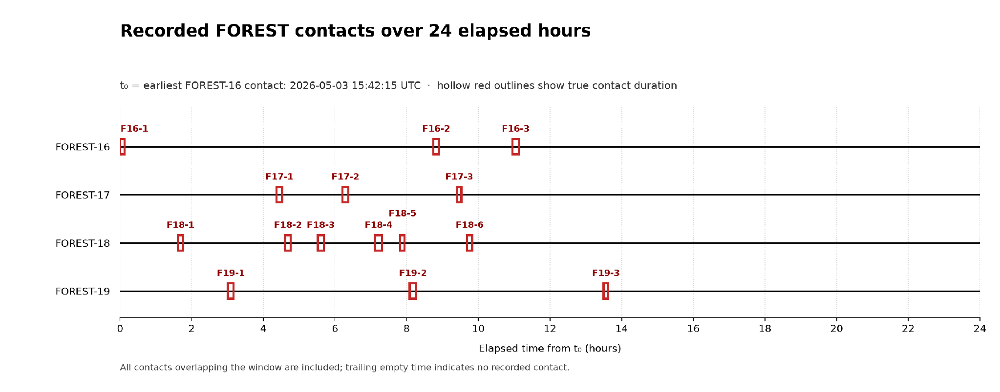
Figure 2. All 61 contacts on an absolute UTC axis. Green segments passed the >=301 presented-Doppler filter; red segments did not.
Green segments passed the >=301 presented-Doppler rule; red segments did not. The compact table later in this document contains only those 15 fitted passes. Exact UTC intervals and counts for all 61 contacts remain in the Markdown and CSV.

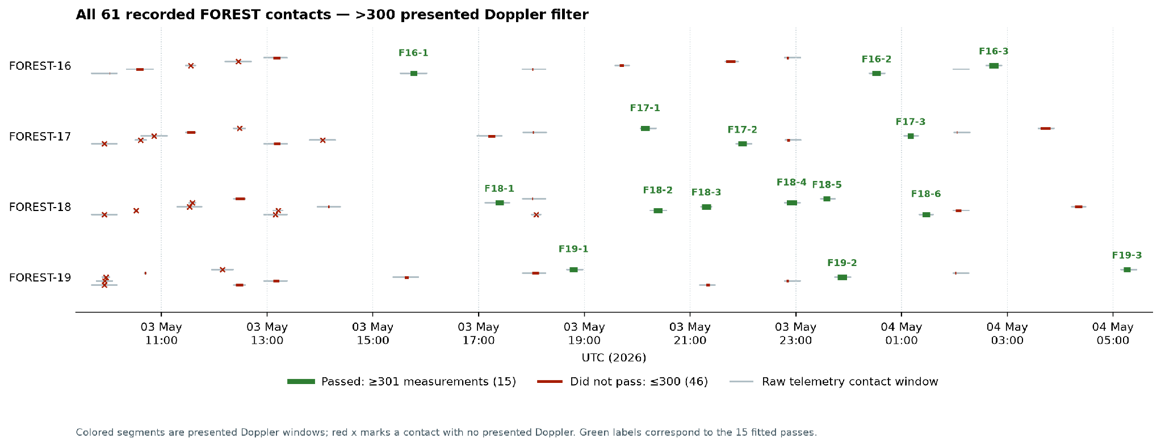
3 Inputs, contact selection, and measurement counts
The checksummed source bundle contains four FOREST Parquet files and twelve raw GPS position/time/velocity exports listed in data_manifest.sha256. The companion forest_leop_may_2026.csv contains one row per raw contact with both TLE lines, exact timestamps, every filtering count, cohort flags, and nullable fit/error fields.
The evaluation consumes the recorded telemetry plus the GPS position and time exports. The velocity exports are retained in the provenance bundle but do not enter the position-error metric.
A presented Doppler measurement is a carrier-frequency-offset sample that is non-null, nonzero, has abs(offset) >= 0.1 Hz, and was recorded with antenna elevation strictly between 1° and 89°. Contacts were eligible for fitting at 301 presented measurements. The GPS threshold affects only the primary accuracy cohort, not fitting.
Selection summary: 176,474 raw telemetry samples contained 67,882 non-null Doppler values, 9,727 nonzero values above the 0.1 Hz floor, and 9,568 presented measurements after the elevation filter. The data cover 61 raw contacts, 15 estimator-eligible contacts, and 11 primary accuracy passes.
By spacecraft, FOREST-16 contributed 13 raw / 3 fitted / 2 primary contacts; FOREST-17 contributed 15 / 3 / 3; FOREST-18 contributed 18 / 6 / 4; and FOREST-19 contributed 15 / 3 / 2.
Of the 46 contacts not fitted, 18 had no presented Doppler and 28 had between 1 and 300 presented measurements. The full Markdown Appendix A lists every contact and makes these exclusions visible.

4 TLE priors
The source TLE is immutable during a fit. DART estimates a pass-constant time shift and evaluates SGP4(t + Δt); it does not rewrite the TLE or fit a six-dimensional state. Every one of the 15 analyzed passes used the spacecraft-specific analysis prior below.

4.1 FOREST-16 analysis prior
TLE epoch: 2026-05-03T09:21:26.64288Z; used by all 3 analyzed FOREST-16 passes.
1 90916U 00000AAA 26123.38989170 .00000000 00000-0 15851-2 0 9996
2 90916 97.7445 21.6711 0001088 184.3194 124.1089 14.91831094 03

4.2 FOREST-17 analysis prior
TLE epoch: 2026-05-03T09:19:03.743328Z; used by all 3 analyzed FOREST-17 passes.
1 90917U 00000AAA 26123.38823777 .00000000 00000-0 15851-2 0 9997
2 90917 97.7396 21.6764 0005261 314.5846 344.9937 14.90540572 06

4.3 FOREST-18 analysis prior
TLE epoch: 2026-05-03T09:20:18.843072Z; used by all 6 analyzed FOREST-18 passes.
1 90918U 00000AAA 26123.38910698 .00000000 00000-0 15851-2 0 9997
2 90918 97.7376 21.6797 0001897 93.2348 211.0047 14.92051430 08

4.4 FOREST-19 analysis prior
TLE epoch: 2026-05-03T09:21:02.043072Z; used by all 3 analyzed FOREST-19 passes.
1 90919U 00000AAA 26123.38960698 .00000000 00000-0 15851-2 0 9993
2 90919 97.7424 21.6734 0001942 141.5194 165.3859 14.92112300 07
The raw archive contains one additional recorded TLE version per spacecraft. Those versions occur only on contacts that did not enter the estimator result. They remain in the 61-row CSV and are reproduced here so the contact history is not silently flattened.
FOREST-16, recorded-only version — 1 contact(s), raw span 2026-05-03 09:40:40.060749 UTC to 2026-05-03 10:09:27.049946 UTC, TLE epoch 2026-05-03T09:23:46.592736Z.
1 90916U 00000AAA 26123.39151149 .00000000 00000-0 15851-2 0 9994
2 90916 97.7617 21.4277 0002400 218.8820 102.0181 14.92272573 07
FOREST-17, recorded-only version — 1 contact(s), raw span 2026-05-03 09:40:38.191475 UTC to 2026-05-03 10:09:32.948508 UTC, TLE epoch 2026-05-03T09:21:23.693184Z.
1 90917U 00000AAA 26123.38985756 .00000000 00000-0 15851-2 0 9993
2 90917 97.7557 21.4315 0006146 306.8621 5.1791 14.90827857 01
FOREST-18, recorded-only version — 1 contact(s), raw span 2026-05-03 09:40:41.120205 UTC to 2026-05-03 10:09:27.977468 UTC, TLE epoch 2026-05-03T09:22:38.792928Z.
1 90918U 00000AAA 26123.39072677 .00000000 00000-0 15851-2 0 9994
2 90918 97.7530 21.4346 0000636 150.6099 166.1032 14.92314271 08
FOREST-19, recorded-only version — 3 contact(s), raw span 2026-05-03 09:40:41.142928 UTC to 2026-05-03 10:09:28.976325 UTC, TLE epoch 2026-05-03T09:23:21.992928Z.
1 90919U 00000AAA 26123.39122677 .00000000 00000-0 15851-2 0 9991
2 90919 97.7594 21.4292 0002309 187.8308 131.5480 14.92510159 09

5 Analyzed contacts and results
Elapsed time is calculated independently for each spacecraft: the first fitted pass of FOREST-16, FOREST-17, FOREST-18, and FOREST-19 each defines that spacecraft’s own T+00:00:00. A later FOREST-17 result, for example, is timed from the first FOREST-17 pass rather than the first pass of another spacecraft. Accuracy is the same-pass full-pass batch-LS median 3-D ITRF position error. N/A means that no same-pass GPS fix was available. Detailed UTC times, counts, fit parameters, and median/RMS fields remain in the Markdown and CSV.
Spacecraft | Contact ID | Time after first pass | Accuracy
FOREST-16 | e5d79f0b-730b-4832-becf-f716d7322784 | T+00:00:00 | 19.154 km
FOREST-16 | 33061519-fa11-49e4-becd-6c770efd6e11 | T+08:44:35 | 1.014 km
FOREST-16 | 556b1cfa-0a8e-4d19-8f95-b123fd47cd60 | T+10:57:04 | 3.013 km
FOREST-17 | 2610bd5f-3a3f-4756-be38-d31392d4324c | T+00:00:00 | 24.856 km
FOREST-17 | 36c92afa-8853-4630-a788-ad2e63912d51 | T+01:50:31 | 3.857 km
FOREST-17 | d623db96-56fd-4783-9f1e-bf3933f4dbd8 | T+05:02:41 | 4.500 km
FOREST-18 | 49e74a6c-b21d-46c0-87bb-e4195b4a0dab | T+00:00:00 | 10.826 km
FOREST-18 | 48de3125-1fd3-40df-be87-5fc55aa2485f | T+02:59:30 | 1.377 km
FOREST-18 | 2735b79f-1ae2-4be6-9b13-774d026efd72 | T+03:54:21 | 4.769 km
FOREST-18 | 7654ef67-7aba-4f18-bf0a-65eacc1b6a22 | T+05:30:24 | 0.307 km
FOREST-18 | 105f1f16-870e-4658-9a38-41c74ea5939c | T+06:12:19 | 1.390 km
FOREST-18 | 8db51bff-de04-4287-b3c8-4f949e7a8df1 | T+08:04:24 | 1.585 km
FOREST-19 | d2af3474-5932-431d-ae42-c7ce901c93ba | T+00:00:00 | 5.249 km
FOREST-19 | df2618ab-46b7-49bb-a148-ea9f89466869 | T+05:04:08 | 0.494 km
FOREST-19 | e629dfe8-8210-4af9-a61d-f02b5377a4fd | T+10:28:44 | N/A (no same-pass GPS)
The four non-primary fits are retained: FOREST-16/SVALSAT has one GPS fix; two FOREST-18/SVALSAT passes have four and three fixes; FOREST-19/SVALSAT has no same-pass GPS. In particular, the 0.307 km FOREST-18 median based on three fixes is supplementary and does not replace the 0.494 km primary best pass.

6 Forward model and solver
For observation epoch t_i, station and SGP4 states are transformed consistently to GCRF, including frame-rotation velocity terms. With relative position ρ and velocity v, range rate and Doppler are
rho_dot = dot(rho, v) / norm(rho)
doppler_hz = -rho_dot * carrier_hz / speed_of_light + frequency_bias_hz
which corresponds to the implementation in measurements.py. The batch fit uses every presented measurement in a contact and only two parameters, [Δt_s, frequency_bias_hz]:
shifted_epochs = [epoch + duration(seconds=state[0]) for epoch in epochs]
predicted = measurement_model.predict_many(context, state, DOPPLER, cache)
residual = (measured_doppler - predicted[:, 0]) / 500.0
least_squares(
residual,
bounds=([-120.0, -100_000.0], [120.0, 100_000.0]),
loss="soft_l1",
f_scale=700.0 / 500.0,
)
The production implementation in batch.py tries initial offsets [-90, -60, -30, 0, 30, 60, 90] s and keeps the successful minimum-cost fit. No numerical prior is supplied. A fit is healthy only when the optimizer succeeds, its scaled Jacobian has rank two and finite condition <=10^12, and neither parameter is on a bound. All 15 passes were healthy; their condition numbers and uncertainty fields are preserved in the CSV.
This is an along-track/time-phase correction model. It cannot repair mean motion, orbital plane, altitude, drag, or cross-track error.

7 Position-error computation
Raw GPS positions are interpreted as ITRF metres at the receiver measurement epoch embedded in the NovAtel export. Packet-arrival timestamps are used only to recover the GPS week and enforce the documented latency filter. For each accepted GPS fix i,
e_i_km = norm(r_ITRF_SGP4(t_i; Δt) - r_ITRF_BESTXYZ(t_i)) / 1000
pass_median_km = median(e_i_km)
pass_rms_km = sqrt(mean(e_i_km ** 2))
The Source-TLE score uses Δt = 0; the batch score uses the full-pass fitted Δt. The primary best/median/worst values are the minimum, median, and maximum of the 11 pass medians, so a high-rate contact or a pass with more GPS fixes cannot dominate by sample count. The implementation is in replay.py and gps.py.

8 Frozen-correction forecast
For each analyzed contact, its full-pass fitted offset is frozen at contact end and scored on later GPS fixes. Each cell below is the median of per-pass median errors; a pass contributes only when that horizon contains at least five fixes.
Frozen-correction summary: at 0–1 h the source/batch errors were 9.676/2.617 km (11/15 improved); at 1–3 h, 12.740/3.509 km (11/15); at 3–6 h, 16.735/5.860 km (11/15); at 6–12 h, 22.378/10.519 km (12/15); and at 12–24 h, 31.735/19.798 km (11/15).

9 Controls against leakage and optimistic reporting
The following controls make the result auditable and harder to inflate:
- Immutable provenance. All 16 telemetry/GNSS source files are named and SHA-256 verified before this report is generated. The CSV records the exact per-contact TLE.
- Complete contact accounting. All 61 contacts are listed, including 46 that fail estimator eligibility, low-GPS passes, the GPS-free pass, and all degraded fits.
- GPS is outside the estimator. fit_batch receives only the TLE/station context and recorded Doppler observations. GPS is selected and scored only after fitting; it cannot initialize, trim, or gate this fit or decide estimator eligibility. The protocol also records that GPS was not used for parameter tuning.
- Fixed mechanical cohort rules. The report reconstructs the documented Doppler filters, 301-measurement estimator threshold, and five-fix primary scoring threshold from the raw files and fails if the resulting 61/15/11 counts differ.
- Independent timing. GPS scoring uses the embedded receiver measurement epoch, not packet arrival. Historical antenna commands are visibility/control metadata, not treated as extra angle measurements.
- Equal pass weighting. Accuracy is summarized across pass medians rather than pooling correlated high-rate Doppler or overlapping GPS samples.
- Evidence scoping. The production bundle is rejected if it contains UKF or phase fields. Synthetic closure and phase experiments remain outside this report.
- Reproducible joins. Generation fails on checksum, inventory, contact-time, sample count, GPS-count, TLE-constancy, or eligibility/result mismatches.
- Independent estimator replay. The commands below reconstruct the inventory and rerun every batch fit from the checksummed sources. In the pinned environment, the regenerated JSON and CSV files are byte-for-byte identical to the checked evidence.
These controls do not make the study blinded or preregistered. The contacts had already been inspected when this retrospective analysis was assembled, and the same-pass score is a full-pass backcast. The appropriate next confirmation is a prospectively frozen protocol evaluated on unseen LEOP contacts. Accordingly, this report demonstrates performance on this recorded cohort and shows potential operational accuracy.

10 Detailed contact evidence
The complete 61-contact table, exact UTC windows, filter-stage counts, GPS coverage, fit diagnostics, TLE lines, and median/RMS fields remain in forest_leop_may_2026.md and forest_leop_may_2026.csv. They are intentionally not duplicated in this compact Word edition.

